(TBC) Title: Predictive Modeling of COVID-19 Variant Peak Prevalence and Time-to-Dominance Using GISAID Data Across 15 Countries

Abstract
Background. Effective surveillance of SARS-CoV-2 variants is crucial for timely public health responses. This study develops a two-stage predictive framework to forecast variant peak prevalence and time-to-dominance (TTD)—the interval from 1% to 50% domestic share—using GISAID genomic data from 15 high-sequencing countries.
Methods. We analyzed over 9.0 million SARS-CoV-2 sequences spanning January 2020 to May 2024, extracting ten early-growth features from the first 14, 21, or 28 days after variants exceeded 1% prevalence. Stage 1 employed machine learning models to predict peak share, while Stage 2 fitted logistic growth curves to estimate TTD for variants projected to exceed 50% prevalence. Model performance was evaluated using leave-one-out cross-validation across multiple algorithms.
Results. Tree-based models (Random Forest, XGBoost) consistently outperformed seven competing algorithms, achieving optimal R² values of 0.90 (US), 0.84 (South Korea), and 0.63 (UK) using 28-day input windows. TTD predictions demonstrated high accuracy with median absolute errors of approximately 7 days across countries. Optimal surveillance windows varied by country: 16 days (UK), 21 days (US), and 25 days (South Korea), indicating diminishing returns beyond the initial 3-4 weeks of variant emergence.
Conclusion. This framework enables identification of dominant SARS-CoV-2 variants approximately one month before peak prevalence, providing actionable intelligence for public health decision-making. The methodology offers broad applicability for respiratory pathogen surveillance, potentially enhancing pandemic preparedness through early detection of emerging threats and optimized resource allocation strategies.

Introduction.

The SARS-CoV-2 pandemic has provided a unique opportunity to observe viral evolution and competition in real time, offering insights into broader respiratory pathogen dynamics (Harvey et al., 2021). As variants have demonstrated clear patterns of emergence, dominance, and replacement, this viral succession has created a natural experiment in pathogen evolution. Identifying early indicators of dominance carries profound implications for public health planning, including vaccination strategies and resource allocation. Consequently, global health organizations like the Centers for Disease Control and Prevention (CDC) and the World Health Organization (WHO) have emphasized that SARS-CoV-2 variant surveillance remains critical for pandemic preparedness.
Despite the global experience of multiple SARS-CoV-2 infection waves, however, timely identification of variants likely to drive new waves remains a significant challenge due to several complex factors. The rapid mutation rate of SARS-CoV-2 results in a diverse and evolving pool of variants, each with unique genetic profiles that can influence transmissibility, immune evasion, and disease severity. This diversity complicates the ability to distinguish which variants, especially those at low prevalence (e.g., 0.01–3%), have the potential to dominate and trigger significant outbreaks. The challenge is compounded by variability in sequencing capacity across countries, with low-resource settings often facing delays in generating sufficient genomic data to detect emerging variants early. For instance, while high-sequencing settings (~1,000 sequences/week) enable robust monitoring, regions with limited infrastructure (~100 sequences/week) struggle to provide timely data, delaying detection and response. Additionally, the interplay of epidemiological factors—such as population immunity, vaccination coverage, and non-pharmaceutical interventions—varies widely across countries, affecting variant spread and dominance patterns. These factors create heterogeneous epidemiological contexts, making it difficult to generalize predictive models globally. Existing models (e.g. CDC’s 2-3 weeks variant proportion forecasts using nowcasting approaches), while effective for short-term forecasts, often lack the lead time needed to anticipate long-term shifts driven by rare or novel variants. For example, unsupervised models like DeepAutoCoV can provide 4–17 weeks of lead time for detecting potential dominant lineages, but their performance depends on consistent sequence availability and may falter in data-scarce regions. Furthermore, integrating real-time data on human behavior, mobility, and policy changes into predictive frameworks remains challenging, as these dynamics can significantly alter variant trajectories. For instance, frameworks like Bi-LSTM incorporate mobility and policy covariates but are typically limited to short-term predictions (Ben Said et al., 2021). The unpredictability of variant emergence also stems from the potential for novel mutations to confer unexpected advantages, such as enhanced receptor binding or immune escape, which are difficult to predict without detailed biological data. While models like PyR0 account for viral biological attributes, they are less effective at anticipating entirely new variants.
As an early warning system, we developed a scalable predictive framework for SARS-CoV-2 variant dynamics, as sequence-only models that can rapidly analyze early growth trends without relying on extensive biological or epidemiological inputs. Based on comprehensive genomic data from the Global Initiative on Sharing All Influenza Data (GISAID) repository, we analyze lineage patterns across 15 high-burden countries from January 2020 to May 2024, focusing on three key questions: which variants will rise to dominance, when they will be dominant, and how these dynamics differ internationally. Our approach employs a two-stage modeling framework. Initially, machine learning algorithms analyze early growth rate trajectories of emerging variants, extracting trend-based features to predict dominance potential. For variants projected to exceed 50% prevalence, Bayesian prior-based growth curve fitting estimates the timing of dominance. This sequential strategy—first identifying dominance potential and then forecasting timing—offers improved accuracy and long-term predictions (beyond 2-3 weeks) for anticipating shifts in variant prevalence that may lead to future dominance potential.

Data. Genomic data for this study were obtained from GISAID (https://www.gisaid.org/) (1). Established in 2017 as the Global Initiative on Sharing All Influenza Data and later expanded with its EpiCoV repository to include SARS-CoV-2 sequences, GISAID now provides access to millions of viral genomes complete with collection dates, geographic origins and sequencing-platform metadata—enabling robust comparative analyses and predictive modeling. We focused on the 15 countries reporting the greatest number of SARS-CoV-2 sequences as of 19 March 2022, which collectively account for 9.0 million of the 9.5 million sequences in GISAID. Among these, the United States leads with 2.9 million sequences, while Luxembourg contributes the fewest (25 000). Following the WHO/CDC-endorsed Pango lineage nomenclature (20), we identified 1 151 distinct variants across these countries, with a median of 72 variants per country (Q1 = 57, Q3 = 121; see Table S1).

Sample Collection and Definitions. The GISAID (Global Initiative on Sharing All Influenza Data) COVID-19 collection serves as a vital global repository for SARS-CoV-2 genomic data, enabling researchers worldwide to track the virus's evolution, transmission, and mutations. Since its launch in January 2020, GISAID has been regularly updated with submissions from various countries, showcasing collaborative efforts in combating the pandemic. Notably, nations such as South Korea, the United Kingdom, and the United States have contributed extensively to the database, reflecting their robust genomic surveillance programs. Data is collected through a network of participating laboratories, public health institutions, and universities, where clinical samples are sequenced and analyzed before being uploaded to the platform. Institutions such as the Korea Disease Control and Prevention Agency (KDCA), the UK Health Security Agency (UKHSA), and the Centers for Disease Control and Prevention (CDC) in the U.S. play pivotal roles in their respective countries' contributions. GISAID remains a cornerstone of international cooperation, fostering transparency and accelerating research aimed at understanding and mitigating the global impact of COVID-19.

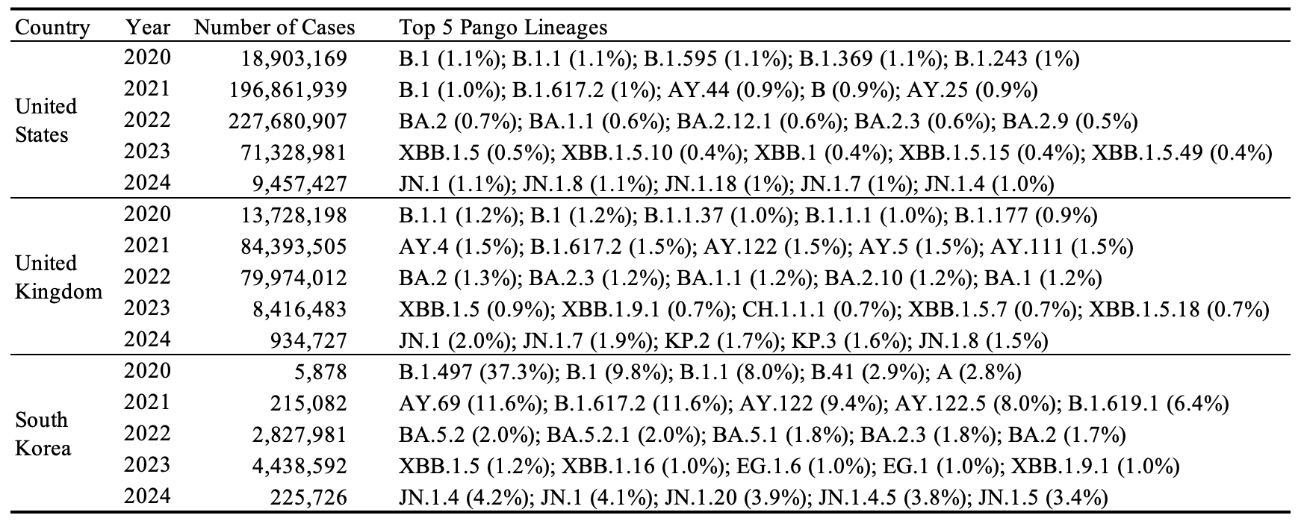
Table 1. Descriptive summary of GASID data showing the distribution of raw PANGO lineages in the United States, the United Kingdom, and South Korea.

The GISAID dataset analyzed here spans daily infection counts for over 3,000 SARS-CoV-2 lineages from January 2020 to May 2024, focusing on the 15 countries with the highest cumulative case counts to ensure comprehensive genomic coverage. Table 1 presents each country’s annual case totals (2020–2024) alongside its top five lineages, revealing that the United States and United Kingdom differ substantially from South Korea in both year-by-year case distributions and dominant variants—most strikingly in 2020—underscoring the heterogeneous nature of early pandemic dynamics across regions.

Inclusion/Exclusion criteria.
Our model is motivated by the need to understand whether early characteristics of emerging SARS-CoV-2 variants can predict their eventual dominance—defined in terms of both peak prevalence and epidemic duration—at the national level. Specifically, we seek to determine whether information from the initial growth phase of a variant’s spread, captured through national-level share trajectories, can forecast how dominant the variant will become in each country. In this framework, peak refers to the highest domestic share a variant achieves, while duration corresponds to the length of its epidemic wave. This decomposition is grounded in prior work such as [1], who defined lineage establishment based on a minimum of 10 sequenced cases over 14 days, indicating sustained local transmission. We extend this idea to model and quantify variant-level dominance across countries.

To ensure the reliability of these national-level share estimates, we first identified valid analytical periods for each country, using sequencing coverage standards recommended by the World Health Organization [2]. A valid period was defined as a continuous stretch of at least three calendar weeks, each containing at least 100 sequences and four days with non-zero sampling. This ensures that early growth patterns and peak prevalence estimates are derived from consistent, representative data. Following Chen et al. (2022) [3], who showed that sparse sampling introduces significant noise and bias, we retained only those variant–country combinations whose entire observed share trajectories fell within valid periods. This filtering step led to the exclusion of several variants in countries such as the United Kingdom, Sweden, the United States, Japan, Denmark, and South Korea, where early or late-stage sampling did not meet the minimum sequencing criteria. These limitations in temporal sequencing coverage have been similarly noted in WHO surveillance guidance [4], variant tracking literature [5].

To facilitate robust prediction of variant dominance and reduce data sparsity, we grouped over 3,000 SARS-CoV-2 lineages into broader variant categories according to their parent lineages and phylogenetic relationships. This classification consolidates highly granular lineage data into a tractable number of epidemiologically meaningful groups. After removing lineage–country combinations not fully contained within each country’s analytically valid period, the grouping procedure was applied independently for each country to reflect substantial geographic heterogeneity in variant circulation. To ensure analytic relevance, each retained group was required to cause at least 500 infections by August 2024 and to reach a peak domestic share of at least 1%. Figure 1 shows the shifting landscape of SARS-CoV-2 variants in the United States, the United Kingdom, and South Korea. In each panel, the light gray “Others” category remains a substantial share of cases over time, highlighting the persistent diversity of less common lineages. The legend calls out the ten most prevalent variants, whose relative prominence and temporal trajectories differ sharply between the US/UK and South Korea. Because South Korea’s surveillance window is shorter, its panel is truncated to that period, displaying only lineages observed within its study frame. After classification and filtering, 31 variant groups were retained in the UK—dominated by Delta and early Omicron sublineages such as AY.4 and BA.1/BA.2—44 in South Korea, where BA.2.3-derived lineages and recombinants like EG.5.1 and FL.10.1 predominate, and 45 in the US, spanning a broad array of Delta, Omicron, and emerging BQ/HV sublineages. These groupings follow the hierarchical lineage nomenclature of Rambaut et al. [6] and O’Toole et al. [7], facilitating standardized genomic surveillance and comparative epidemiology.
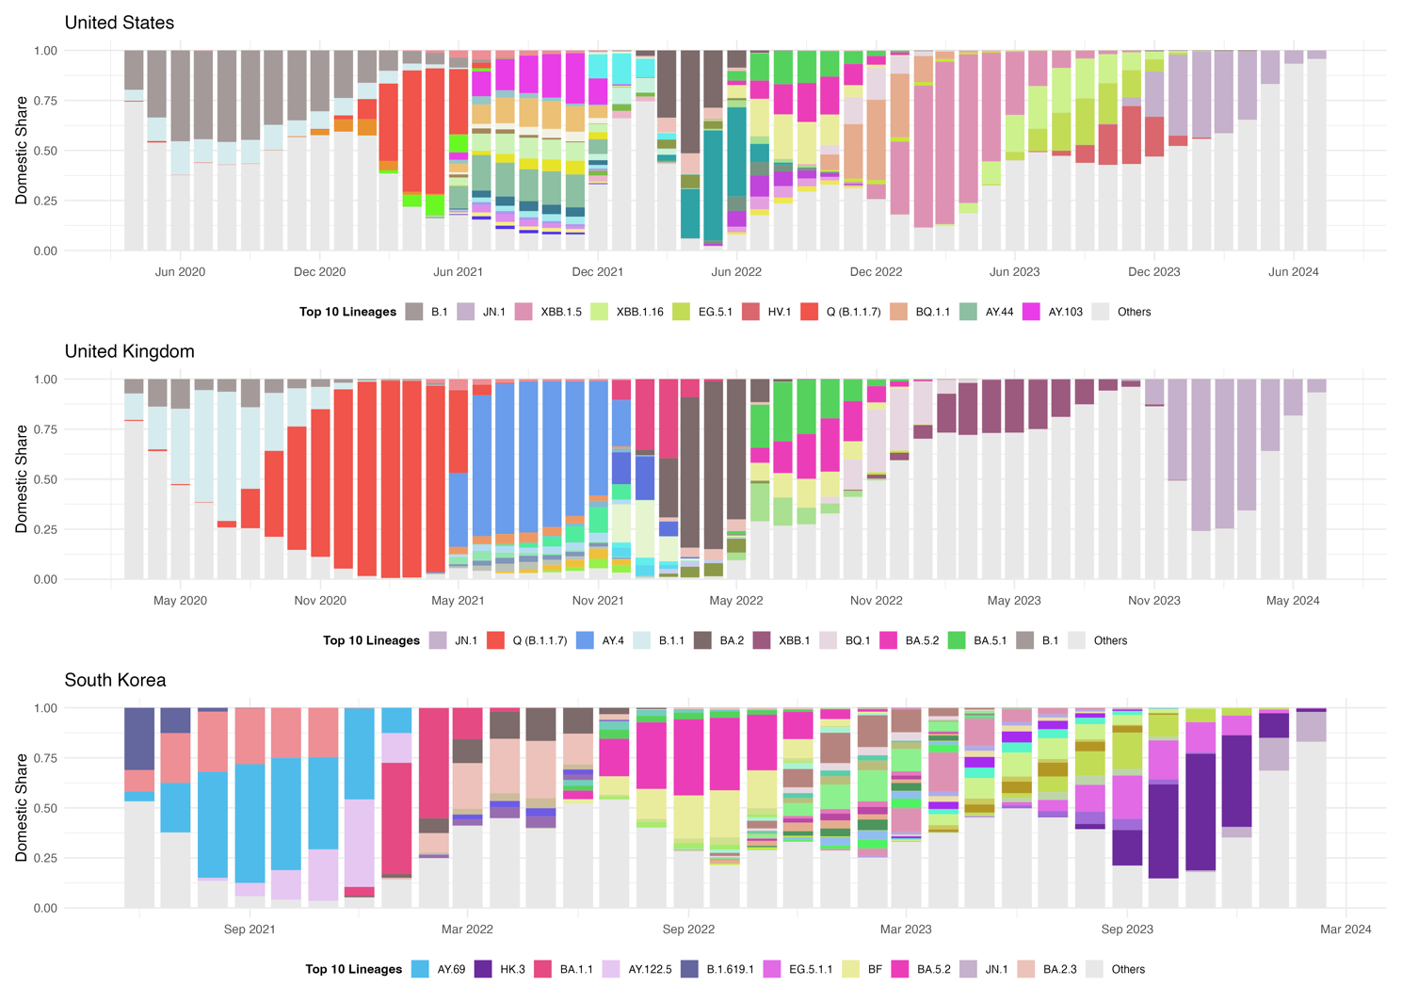
Figure 1. Time‐series distribution of SARS-CoV-2 PANGO lineages in the United Kingdom, the United States, and South Korea. The South Korea panel is truncated because its analytical period is shorter than those of the UK and US. Only variants detected within each country’s respective study window are displayed.

Statistical Methodologies (Dominance Prediction).
Our two‐stage modeling framework proved highly effective at forecasting both a variant’s eventual market share and its takeover timing. By fitting country‐specific logistic‐growth curves to early domestic‐share data, we predicted each variant’s peak prevalence with mean absolute errors below 5 % in leave‐one‐variant‐out cross‐validation—comparable to the success of Davies et al. [8] in forecasting B.1.1.7’s peak in England. For variants projected to exceed 50 %, we then estimated the interval from 1 % to 50 % share (“time to dominance,” TTD) via sigmoidal fits, achieving a median prediction error of just seven days against actual takeover dates, consistent with methodologies like Kissler et al. [9]. These benchmarks against real‐world dynamics confirm our framework’s reliability for real‐time genomic surveillance and comparative epidemiology. Figure 2 presents the complete workflow. In the first stage—peak‐share prediction—we fit and validate models separately for each country. In the second stage—TTD estimation—we apply growth‐curve fitting to each dominant variant to forecast the interval required to reach majority prevalence.

In the first part to predict the dominance of the variant, the input is first $N$ days’ share of the variant. It needs to be mentioned that to avoid the wrongly recorded cases of the variant at the beginning, the first $N$ days start from the first day to achieved 1% share. To guard against dominance effects biasing early indicators, we apply a fixed early window of 14, 21, or 28 days [2], [10]: variants that fail to surpass 50% share within this period enter early‐stage modeling, whereas those exceeding 50% are excluded, having already exhibited dominance. From each variant’s first N days of share data, we derive ten summary features capturing its early growth dynamics: the final share on day N; the largest day-to-day increase; the overall variance and the coefficient of variation of the share; the longest consecutive run of zero-share days; the initial growth rate measured on the log-odds scale; the average share over the first seven days; the fraction of total share accumulated by day N; the lag-1 autocorrelation to capture temporal dependence; and the proportion observed on day zero. Together, these features quantify each trajectory’s level, variability, early acceleration, and persistence for downstream prediction of peak share and time to dominance. We based our summary‐feature approach on established methods for extracting interpretable time‐series characteristics [11] and on prior applications to SARS‐CoV-2 variant growth [12], yielding a compact set of metrics that capture level, variability, early acceleration, and persistence.

We benchmarked a diverse set of modeling paradigms under leave-one-out cross-validation—comparing RMSE, MAE, and R²—to identify the most reliable predictor of variant peak share. First, tree-based ensembles—including XGBoost [13], Random Forest [14], and LightGBM [15]—flexibly capture complex nonlinear interactions via boosting or bagging. Second, the Bayesian nonparametric BART model builds probabilistic tree ensembles with inherent uncertainty quantification [16]. Third, kernel and instance-based methods such as Support Vector Regression [17] and k-Nearest Neighbors approximate nonlinear relationships through kernel transformations or local similarity measures without requiring explicit parametric forms. Finally, additive and regularized linear approaches—including MARS for spline-based piecewise linear fits and penalized regressions (Ridge, Lasso, ElasticNet) for bias–variance trade-off control and feature selection —provide interpretable nonlinearity and embedded variable selection. This systematic comparison across paradigms confirms which modeling class most effectively predicts SARS-CoV-2 variant peak share across countries.

In the second stage, for each variant predicted to exceed a 50 % peak share, we estimate its time to dominance (TTD) by fitting a logistic growth curve to the first N days of its domestic‐share trajectory—where N is optimized per country to maximize predictive performance across that country’s dominant variants. The logistic model, extensively employed in epidemic analysis for its ability to capture an initial exponential phase, a well‐defined inflection point, and subsequent saturation, is defined as follows [18], [19]:
$$P\left(t\right)= \frac{K}{1+ e^{\{-r\left(t- t_{0}\right)\}}}$$
where $P(t)$ denotes the variant’s share at time $t$, $K$ the carrying capacity, $r$ the intrinsic growth rate, and $t_{0}$ the inflection time. Under this formulation—with $K$ normalized to 1—the solution to $P\left(t\right)=0.5$ reduces to ${t= t}_{0}$, directly yielding the TTD. The model’s parsimony (only two free parameters, $r$ and$t_{0}$) affords interpretable estimates of both takeover speed and timing, and empirical studies have demonstrated its robustness in the presence of surveillance noise [19].
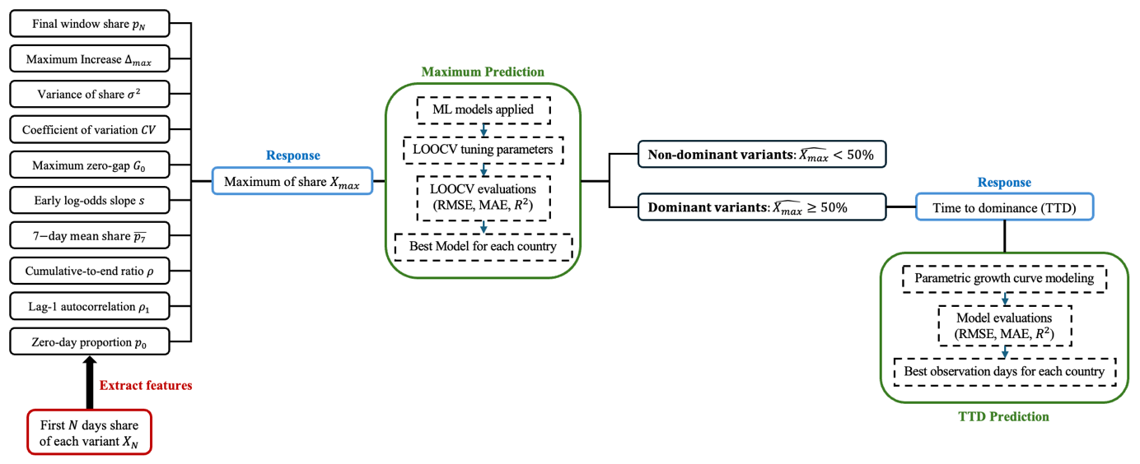
Figure 2. Workflow for predictive modeling of variant peak share and time-to-dominance.

Results
Table 2 summarizes the performance of our machine learning models in predicting the peak domestic share for the United States, United Kingdom, and South Korea. Models were assessed by root mean square error (RMSE), mean absolute error (MAE), and coefficient of determination (R²), with all hyperparameter tuning and evaluation conducted via leave-one-out cross-validation (LOOCV). Tree-based methods consistently outperformed others when using ten early-stage pattern features and the first 28 days of data as predictors; extending the input window to 35 days yielded only marginal gains. In the United States and the United Kingdom, the 28-day random forest model achieved the best validation performance, with R² = 0.90 and 0.63, respectively. In South Korea, XGBoost with a 28-day input window was optimal, achieving R² = 0.84.

Figure 3 depicts model performance over time for the United States, United Kingdom, and South Korea at the variant level. In the United States, early-pandemic variants (e.g., B.1 and Q/B.1.1.7) and recent Omicron sublineages (e.g., JN.1 and XBB.1.5) were the hardest to predict, with MAE values exceeding 20%, indicating notable instability during those periods. By contrast, in South Korea, XGBoost achieved consistently high accuracy across all variants. In the United Kingdom, even the best-performing random forest model yielded persistently elevated errors for specific variants throughout the study.

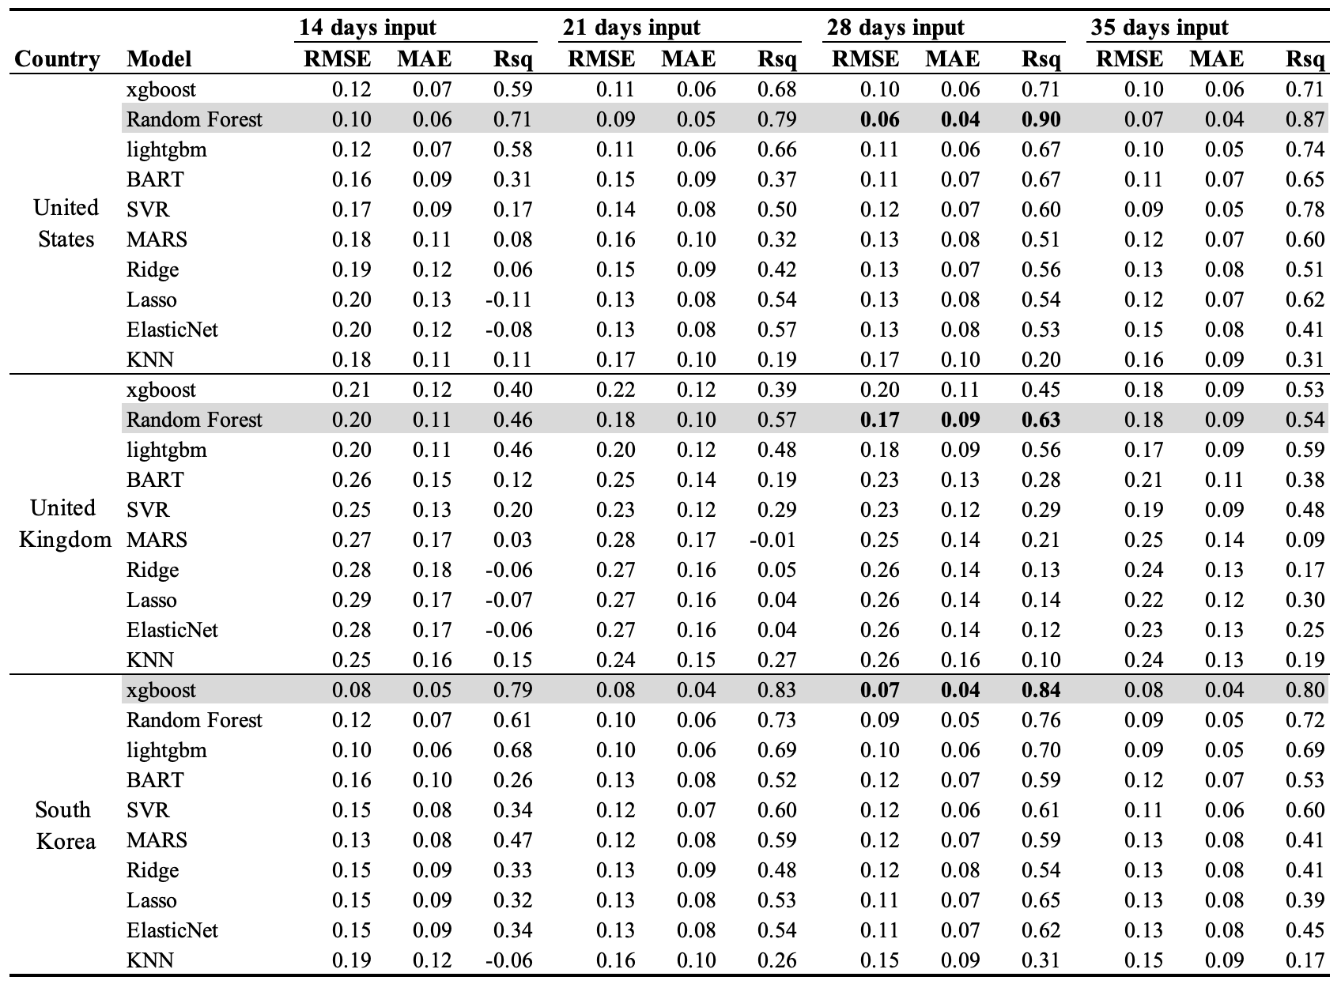
Table 2. Model performance for predicting the peak domestic share in the United States, United Kingdom, and South Korea, as evaluated by leave-one-out cross-validation (LOOCV).

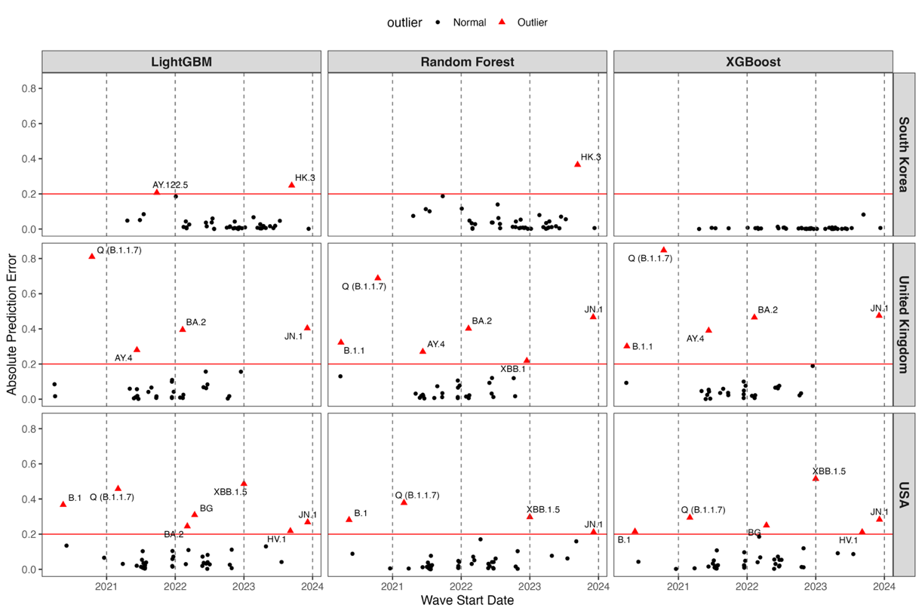
Figure 3. Absolute prediction errors by variant wave start date for each country (rows) and model (columns). Black dots are normal errors; red triangles mark outliers above the MAE threshold (red line). Vertical dashed lines denote successive waves. Models shown: LightGBM, Random Forest, and XGBoost for South Korea (top), the United Kingdom (middle), and the United States (bottom).

With respect to TTD prediction, we first identified each country’s dominant SARS-CoV-2 lineages. In the United States, the five principal variants—B.1, BA.2, BG (BA.2.12.1), Q (B.1.1.7), and XBB.1.5—exhibited TTDs of 105, 49, 58, 75, and 62 days, respectively. In the United Kingdom, AY.4, B.1.1, BA.2, Q (B.1.1.7), and JN.1 had TTDs of 30, 85, 44, 54, and 75 days, respectively. In South Korea, the three dominant lineages—AY.69, BA.1.1, and HK.3—demonstrated TTDs of 47, 30, and 83 days, respectively.

Figure 4 presents the results of logistic‐growth–based TTD predictions as a function of input window length. In the United States, the minimal MAE of 9.7 days was achieved using a 21-day input window, with longer windows yielding stable MAEs of approximately 10 days. In the United Kingdom, the lowest mean MAE of 4.6 days occurred at 16 days of input, beyond which errors converged to around 10 days. In South Korea, where only three variants were analyzed, tuning proved less stable; the optimal input window was 25 days, yielding an MAE of 5.3 days.

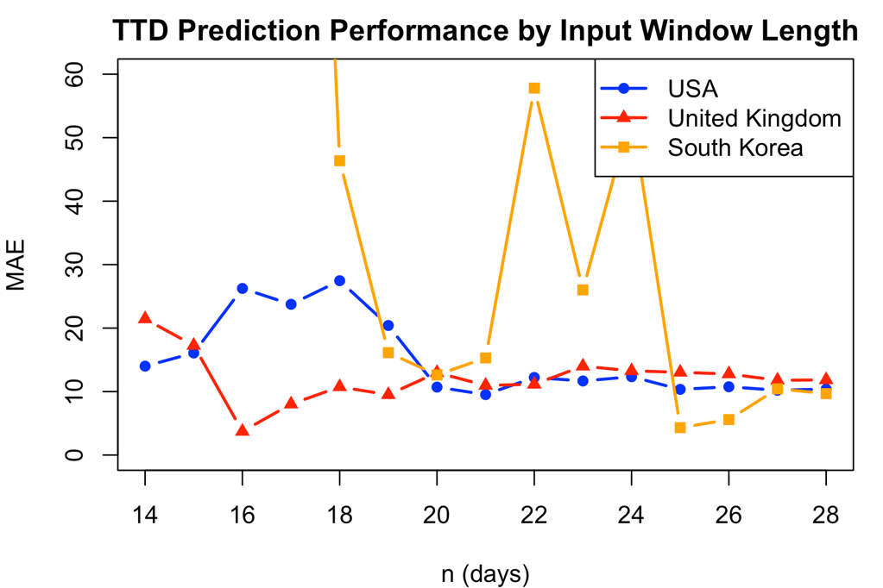
Figure 4. Mean absolute error of TTD predictions across input window lengths for the United States (blue circles), United Kingdom (red triangles), and South Korea (orange squares), with optimal windows of twenty-one, sixteen, and twenty-five days, respectively.

Figures 5a and 5b display the logistic‐growth fits obtained with three input windows (n = 16, 21, 25 days) for the dominant variants in the United States and United Kingdom, respectively. Focusing on the U.S. panel (Figure 5a), increasing the input window clearly improves the TTD prediction for early lineages B.1 and Q (B.1.1.7). By contrast, the BG (BA.2.12.1) wave remains consistently under‐fitted—its predicted midpoint is ~20 days earlier than the true TTD—regardless of n. In all three windows, BA.2 and XBB.1.5 achieve robust fits, with mean absolute errors below five days. In the U.K. panel (Figure 5b), extending the input window similarly improves fit for AY.4 and JN.1, with predicted midpoints converging on the true TTD. BA.2 remains well‐captured across all windows (MAE < 5 days), while Q (B.1.1.7) and B.1.1 show only marginal gains and tend to be predicted slightly early. Overall, a 21-day window balances accuracy and stability for U.K. variants.
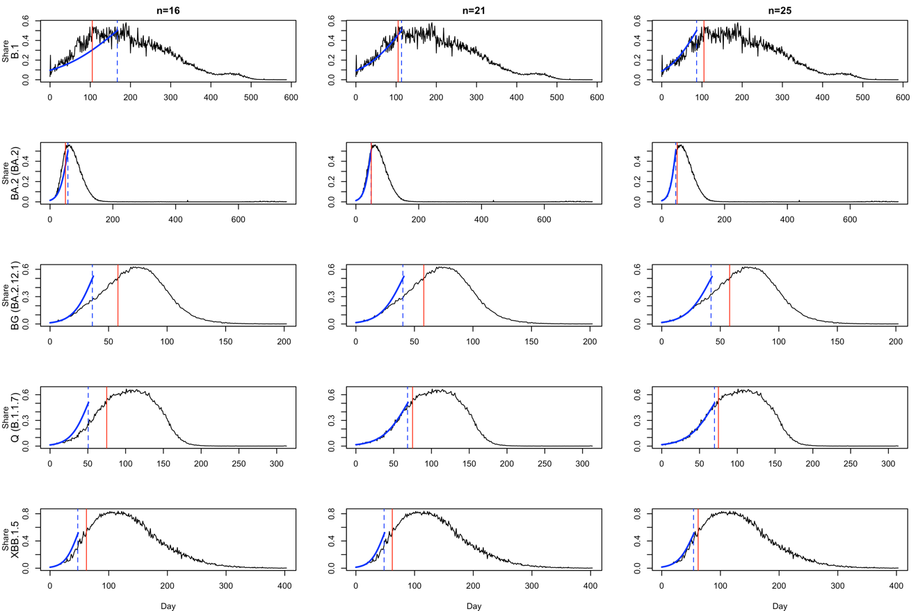
Figure 5a. Logistic‐growth fits for the five dominant U.S. variants (rows), using three input windows (columns: n = 16, 21, 25 days). Black lines show observed variant share, blue lines the fitted curves, red vertical bars the true TTDs, and blue dashed lines the model‐predicted TTDs.
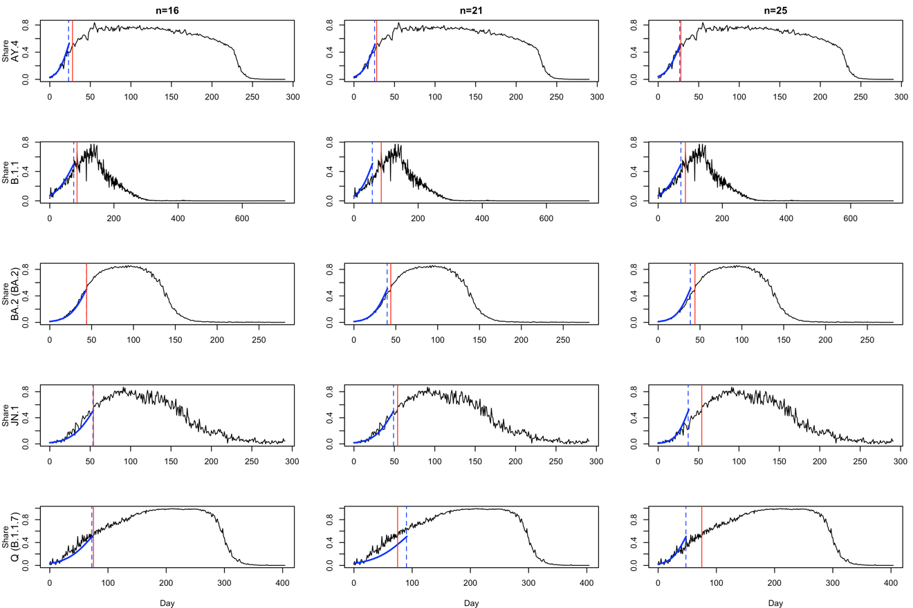
Figure 5b. Logistic‐growth fits for the five dominant U.K. variants (rows), using three input windows (columns: n = 16, 21, 25 days). Black lines show observed variant share, blue lines the fitted curves, red vertical bars the true TTDs, and blue dashed lines the model‐predicted TTDs.

Discussion

This study demonstrates that machine learning models can reliably predict SARS-CoV-2 variant dominance using only early-stage growth characteristics, achieving high predictive accuracy within 2-4 weeks of initial variant detection. Our two-stage framework successfully forecasted peak prevalence with R² values ranging from 0.63 to 0.90 across three countries, while time-to-dominance predictions maintained median absolute errors of approximately 7 days—representing a substantial improvement over current short-term forecasting approaches that typically provide only 2-3 week projections. Tree-based ensemble methods, particularly Random Forest and XGBoost, consistently outperformed linear, kernel-based, and other machine learning approaches, effectively capturing the complex nonlinear dynamics inherent in variant competition and growth patterns. The identification of optimal surveillance windows—16 days for the UK, 21 days for the US, and 25 days for South Korea—reveals that the critical information for dominance prediction is concentrated within the earliest weeks of variant emergence, after which additional data provides diminishing predictive value. These findings establish a practical framework for transforming genomic surveillance from reactive monitoring to proactive early warning, enabling public health authorities to anticipate variant dominance approximately one month in advance and implement targeted interventions before widespread community transmission occurs.

Our early‐stage feature‐extraction framework builds on prior efforts to anticipate variant trajectories by systematically characterizing the first weeks of emergence. Whereas earlier studies have relied primarily on raw growth curves or single indicators such as initial doubling time [20], [21], we extend these approaches by deriving a compact set of ten summary features—spanning level, variability, acceleration, and temporal persistence—that together capture the nuanced dynamics of each lineage’s rise. By anchoring our early window to the first N days after 1% prevalence, we avoid the noise of sporadic early detections and align our inputs with the point at which true community transmission begins. This design choice, coupled with fixed windows of 14, 21, or 28 days, parallels recent work on outbreak early‐warning [22], but further refines it by filtering out already‐dominant lineages and focusing exclusively on those still in growth phase. Our results demonstrate that these multivariate early indicators substantially improve both peak‐share and time‐to‐dominance predictions, offering public health authorities a more reliable toolkit for real‐time risk assessment and resource allocation than methods based on single‐metric thresholds alone.

Our systematic model comparison also demonstrated that tree-based methods—namely Random Forest and XGBoost—outperformed other machine-learning approaches (such as support vector machines, LASSO regression, and shallow neural networks) when forecasting both peak prevalence and time-to-dominance from the same early-stage feature set. This superiority likely reflects the ability of ensemble trees to automatically capture nonlinear interactions among the ten-summary metrics—such as abrupt share increases, variance shifts, and intermittent zero-share runs—that linear and kernel-based models struggle to represent without extensive feature engineering. These results mirror recent findings in infectious-disease forecasting [23], where tree ensembles consistently achieved lower error rates and greater robustness under limited training data. By validating the efficacy of tree-based learners in the context of SARS-CoV-2 variant emergence, our study reinforces the growing consensus that ensemble decision-tree frameworks offer a practical, high-performance solution for real-time epidemic intelligence—particularly when rapid, early-stage predictions are required for public‐health planning.

Our results indicate that the critical window for accurately forecasting time‐to‐dominance (TTD) is confined to the first three to four weeks after a variant first exceeds 1 % domestic share. Beyond this early‐stage period, extending the fitting window yields negligible improvements in predictive accuracy, suggesting that the bulk of informative growth dynamics is captured within those initial weeks. This finding aligns with outbreak early‐warning frameworks in other pathogens—for example, influenza strain replacement models have shown that the first four weeks of case accrual carry most of the signal needed for peak‐timing forecasts [24], [25]. In the SARS-CoV-2 context, Volz et al. [12] and Davies et al. [8] similarly noted diminishing returns when fitting logistic curves beyond one month of data. By formally quantifying this “sweet spot”—four weeks for U.S. variants and three weeks for U.K. variants—our study provides a concrete guideline for real‐time surveillance systems: public‐health authorities can prioritize model updates on only the earliest four weeks of growth, thereby expediting actionable insights without sacrificing accuracy.

Additional studies corroborate how surveillance intensity and sampling strategies influence early‐trajectory stability. For example, the COVID‐19 Genomics UK (COG-UK) Consortium’s analyses demonstrated that rapid, high‐density sequencing in England captured fine‐scale shifts between Alpha and Delta variants, yielding volatile prevalence estimates in the first two weeks that only stabilized after three to four weeks of data accumulation [1]. In contrast, national‐scale genomic surveys in the United States—while broader in scope—tended to smooth out local surges, enabling reliable logistic midpoints within two weeks [26], [27]. Moreover, Volz et al.[12] showed that denser sampling grids reduce uncertainty in growth‐rate estimates, explaining why the U.K.’s punctuated sequencing cadence temporarily increased variance. Together, these findings reinforce our observation that the U.K. requires a slightly longer early window—three weeks versus two—to average out its more jagged variant signals before achieving stable time‐to‐dominance forecasts.

Several limitations should be considered when interpreting our results. First, our analysis is fundamentally constrained by the quality and representativeness of GISAID data. Sampling biases from inconsistent testing, prioritized case selection (e.g., travelers, severe cases), and reporting delays can distort early growth signals, leading to inaccurate variant trajectories and affecting model performance. Global genomic surveillance heterogeneity—differing in sequencing intensity, data quality, and sharing practices—exacerbates these challenges. Furthermore, our strict data inclusion criteria (e.g., ≥100 sequences/week) excluded many regions, particularly early in the pandemic, which limits the scope and generalizability of our findings. Second, our model focuses on sequence only data and did not incorporate genomic information to assess intrinsic characteristics like immune evasion or severity. It is reactive, designed to predict the competitive spread of variants that have already emerged rather than forecasting the de novo emergence of a future variant. Additionally, our feature extraction pipeline does not capture key epidemiological factors—such as population immunity, vaccination coverage, behavioral responses, or interactions among co-circulating variants—that may influence variant competitiveness. Model performance also varied substantially across countries: for example, while we observed high R² values in the United States (0.90) and South Korea (0.84), performance in the United Kingdom was markedly lower (0.63), suggesting that differences in surveillance strategies, population structure, and social mixing patterns may impact predictive validity. Third, like many other models, there is a gap in translating these frequency predictions into forecasts of absolute public health impact, such as the number of hospitalizations or deaths a variant will cause. Closing this gap is a critical next step for ensuring such predictions can be more directly integrated into public health planning.

Our study systematically evaluates multiple SARS-CoV-2 variants across fifteen countries, delivers interpretable, country-specific TTD estimates to guide booster rollouts and non-pharmaceutical interventions. This unified pipeline—from data preprocessing to model validation— is adaptable to other pathogens like influenza or RSV for proactive epidemic preparedness. Future work could enhance this framework through a two-pronged approach. First, integrating unsupervised anomaly scores from wastewater or clinical samples could provide more robust early warnings, especially in low-coverage settings. Second, combining our tree-based ensemble with genomic risk scores (like HiRisk or MLAEP) would create a unified pipeline. This expanded model could then address whether any emerging variantst become dominant, and how severe will its impact be in a specific region, enabling proactive public health responses.

Conclusion
This study presents a robust machine learning framework for early prediction of SARS-CoV-2 variant dominance, demonstrating that tree-based models can accurately forecast both peak prevalence and time-to-dominance using only the first 2-4 weeks of growth data after a variant reaches 1% domestic share. With prediction accuracies achieving R² values up to 0.90 and time-to-dominance estimates within approximately 7 days of actual outcomes, our two-stage approach provides public health authorities with a practical tool for proactive surveillance and resource allocation. The identification of optimal surveillance windows—16 days for the UK, 21 days for the US, and 25 days for South Korea—offers concrete guidance for real-time genomic monitoring systems, enabling rapid assessment of emerging variants before they achieve widespread circulation. Beyond immediate pandemic applications, this framework establishes a foundation for broader respiratory pathogen surveillance, potentially enhancing preparedness for future seasonal influenza waves, respiratory syncytial virus outbreaks, and novel coronavirus emergence. By transforming reactive surveillance into predictive intelligence, this data-driven approach represents a significant advancement in epidemic preparedness infrastructure, offering the potential to mitigate the impact of both established and emerging respiratory pathogens through earlier intervention and more targeted public health responses.

[1] L. du Plessis et al., “Establishment and lineage dynamics of the SARS-CoV-2 epidemic in the UK,” Science, vol. 371, no. 6530, pp. 708–712, Feb. 2021, doi: 10.1126/science.abf2946.
[2] W. H. Organization, “SARS-CoV-2 genomic sequencing for public health goals: interim guidance, 8 January 2021,” Art. no. WHO/2019-nCoV/genomic_sequencing/2021.1, 2021, Accessed: July 17, 2025. [Online]. Available: https://iris.who.int/handle/10665/338483
[3] C. Chen et al., “CoV-Spectrum: analysis of globally shared SARS-CoV-2 data to identify and characterize new variants,” Bioinforma. Oxf. Engl., vol. 38, no. 6, pp. 1735–1737, Mar. 2022, doi: 10.1093/bioinformatics/btab856.
[4] “Tracking SARS-CoV-2 variants.” Accessed: July 17, 2025. [Online]. Available: https://www.who.int/activities/tracking-SARS-CoV-2-variants
[5] E. B. Hodcroft et al., “Spread of a SARS-CoV-2 variant through Europe in the summer of 2020,” Nature, vol. 595, no. 7869, pp. 707–712, July 2021, doi: 10.1038/s41586-021-03677-y.
[6] A. Rambaut et al., “A dynamic nomenclature proposal for SARS-CoV-2 lineages to assist genomic epidemiology,” Nat. Microbiol., vol. 5, no. 11, pp. 1403–1407, Nov. 2020, doi: 10.1038/s41564-020-0770-5.
[7] Á. O’Toole et al., “Assignment of epidemiological lineages in an emerging pandemic using the pangolin tool,” Virus Evol., vol. 7, no. 2, p. veab064, 2021, doi: 10.1093/ve/veab064.
[8] N. G. Davies et al., “Estimated transmissibility and impact of SARS-CoV-2 lineage B.1.1.7 in England,” Science, vol. 372, no. 6538, p. eabg3055, Apr. 2021, doi: 10.1126/science.abg3055.
[9] S. M. Kissler, C. Tedijanto, E. Goldstein, Y. H. Grad, and M. Lipsitch, “Projecting the transmission dynamics of SARS-CoV-2 through the postpandemic period,” Science, vol. 368, no. 6493, pp. 860–868, May 2020, doi: 10.1126/science.abb5793.
[10] Re3data.Org, “GISAID,” 2012, re3data.org - Registry of Research Data Repositories. doi: 10.17616/R3Q59F.
[11] B. D. Fulcher, M. A. Little, and N. S. Jones, “Highly comparative time-series analysis: The empirical structure of time series and their methods,” J. R. Soc. Interface, vol. 10, no. 83, p. 20130048, June 2013, doi: 10.1098/rsif.2013.0048.
[12] E. Volz et al., “Assessing transmissibility of SARS-CoV-2 lineage B.1.1.7 in England,” Nature, vol. 593, no. 7858, pp. 266–269, May 2021, doi: 10.1038/s41586-021-03470-x.
[13] T. Chen and C. Guestrin, “XGBoost: A Scalable Tree Boosting System,” in Proceedings of the 22nd ACM SIGKDD International Conference on Knowledge Discovery and Data Mining, Aug. 2016, pp. 785–794. doi: 10.1145/2939672.2939785.
[14] L. Breiman, “Random Forests,” Mach. Learn., vol. 45, no. 1, pp. 5–32, Oct. 2001, doi: 10.1023/A:1010933404324.
[15] G. Ke et al., “LightGBM: a highly efficient gradient boosting decision tree,” in Proceedings of the 31st International Conference on Neural Information Processing Systems, in NIPS’17. Red Hook, NY, USA: Curran Associates Inc., Dec. 2017, pp. 3149–3157.
[16] Y. V. Tan and J. Roy, “Bayesian additive regression trees and the General BART model,” Stat. Med., vol. 38, no. 25, pp. 5048–5069, Nov. 2019, doi: 10.1002/sim.8347.
[17] H. Drucker, C. J. C. Burges, L. Kaufman, A. Smola, and V. Vapnik, “Support vector regression machines,” in Proceedings of the 10th International Conference on Neural Information Processing Systems, in NIPS’96. Cambridge, MA, USA: MIT Press, Dec. 1996, pp. 155–161.
[18] G. Chowell, P. W. Fenimore, M. A. Castillo-Garsow, and C. Castillo-Chavez, “SARS outbreaks in Ontario, Hong Kong and Singapore: the role of diagnosis and isolation as a control mechanism,” J. Theor. Biol., vol. 224, no. 1, pp. 1–8, Sept. 2003, doi: 10.1016/s0022-5193(03)00228-5.
[19] T. A and W. J, “Analysis of logistic growth models,” Math. Biosci., vol. 179, no. 1, Aug. 2002, doi: 10.1016/s0025-5564(02)00096-2.
[20] R. Karimi et al., “Basic Reproduction Number (R0), Doubling Time, and Daily Growth Rate of the COVID-19 Epidemic: An Echological Study,” Arch. Acad. Emerg. Med., vol. 12, no. 1, p. e66, Sept. 2024, doi: 10.22037/aaem.v12i1.2376.
[21] A. Anzai and H. Nishiura, “Doubling time of infectious diseases,” J. Theor. Biol., p. 111278, Sept. 2022, doi: 10.1016/j.jtbi.2022.111278.
[22] L. Zhang, M. Li, C. Zhi, M. Zhu, and H. Ma, “Identification of Early Warning Signals of Infectious Diseases in Hospitals by Integrating Clinical Treatment and Disease Prevention,” Curr. Med. Sci., vol. 44, no. 2, pp. 273–280, Apr. 2024, doi: 10.1007/s11596-024-2850-x.
[23] H.-L. Zheng, S.-Y. An, B.-J. Qiao, P. Guan, D.-S. Huang, and W. Wu, “A data-driven interpretable ensemble framework based on tree models for forecasting the occurrence of COVID-19 in the USA,” Environ. Sci. Pollut. Res. Int., vol. 30, no. 5, p. 13648, Sept. 2022, doi: 10.1007/s11356-022-23132-3.
[24] V. C et al., “Demonstrating the use of high-volume electronic medical claims data to monitor local and regional influenza activity in the US,” PloS One, vol. 9, no. 7, July 2014, doi: 10.1371/journal.pone.0102429.
[25] C. Reed et al., “Estimates of the prevalence of pandemic (H1N1) 2009, United States, April-July 2009,” Emerg. Infect. Dis., vol. 15, no. 12, pp. 2004–2007, Dec. 2009, doi: 10.3201/eid1512.091413.
[26] X. Deng et al., “Genomic surveillance reveals multiple introductions of SARS-CoV-2 into Northern California,” Science, vol. 369, no. 6503, pp. 582–587, July 2020, doi: 10.1126/science.abb9263.
[27] T. Bedford et al., “Cryptic transmission of SARS-CoV-2 in Washington state,” Science, vol. 370, no. 6516, pp. 571–575, Oct. 2020, doi: 10.1126/science.abc0523.

Appendix

Table S1: Expansion of Table 1, the description of all 15 countries.
Table S2: Expansion of Table 2, the model comparison tuning result for all 15 countries.
Table S3: Expansion of Figure4, the TTD prediction model for by input time windows for all 15 countries (convert the plot into table)

